University of North Carolina Wilmington
MIS 323 – Business Telecommunications
Exercise 7 - Network Design Case 2
Objective: Your task is to design a network for a two story office building in downtown Wilmington. Complete the cost estimate on the spreadsheet at the end of this document. Also, provide a summary describing the network you are suggesting and why you choose the specific technology in your design.
Remember to use the network design process in the book as you design your network.
The building will be used by one company that also has offices elsewhere in the U.S. The building is about 140 feet by 90 feet. I have attached a set of floor plans for the first, and second floors of the building, which is currently under construction. These are actually the floor plans for a new Optometry building, but we’re going to pretend that this is a regular office building. Please assume that every unusually labeled room (e.g., “exam,” “test,” “child,” “cashier”) is an office. We’ll pretend that the “Essilor eye wear center” is a retail shop.
The network has 80 desktop computers and four servers, plus whatever hubs, switches, routers, cable, etc. that you choose to use. You are to select the equipment you will use for the network. I have attached a list of possible equipment. You may want to buy equipment that is not on this list; if so, please come talk to me and I’ll tell you how much it costs. Use the worksheet to record the device/cables with their descriptions and costs.
Use the floor plan to describe where you would place the technologies you have chosen. Include this discussion in the Summary of Design at the end of this document.
Once you have all the devices and equipment installed on your floor plan, calculate the total cost of your network design.
Within the Summary, write one aspect of the network design that you think is its best feature and one aspect that you are concerned about that could be a problem.

Additional Factors to Consider:
- The company is considered to have moderate needs from their network (e.g. 100 Mbps met their needs at their previous location). However, the company is expanding which has the potential to increase their network needs.

- They have 3 additional offices in which they would like to have direct connections to. These are located in Dallas, Chicago and Los Angeles.

- Assume the computers that will be purchased for the building will have 10/100/1000Base-T Network Interface Cards (i.e. you do not need to include NIC cost in your estimates)

- Desktops will be split evenly between the floors (i.e. 40 on the 1st floor and 40 on the 2nd floor)

- There will be an additional 20 laptops that need wireless access (these are primarily located around the retail space on the first floor and will have built-in wireless-g NICs)

- The Cable Costs (including installation) listed on the equipment list is for one computer connection only (e.g. if you have 50 computers, you will need to have 50 wires)

- Remember, there are four servers that must be located somewhere within the building. You can mark these on the diagram using an “S”.

First Floor
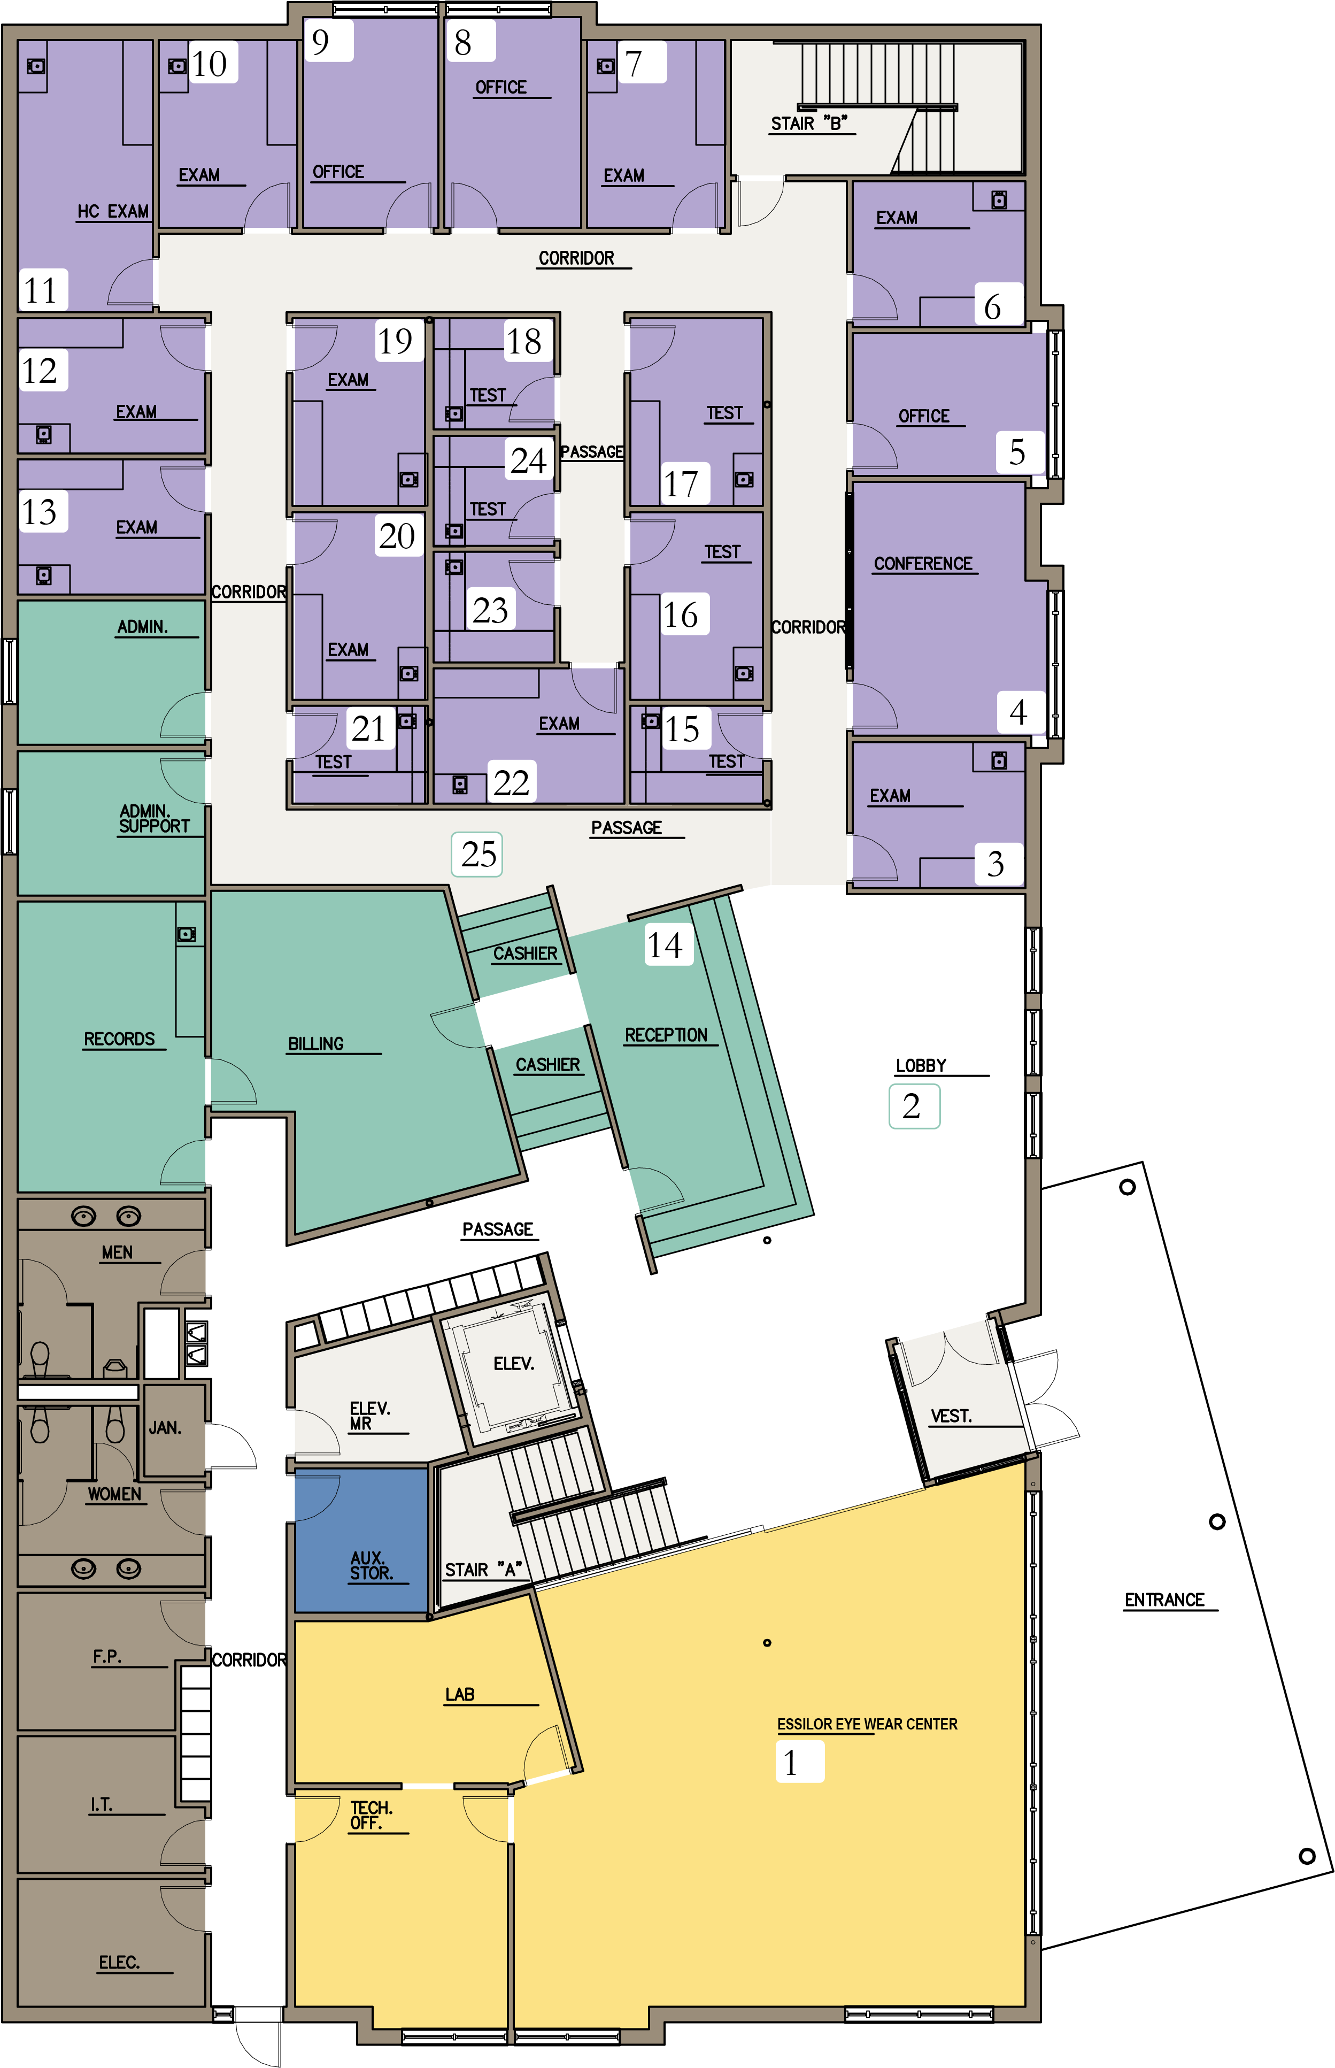

Second Floor
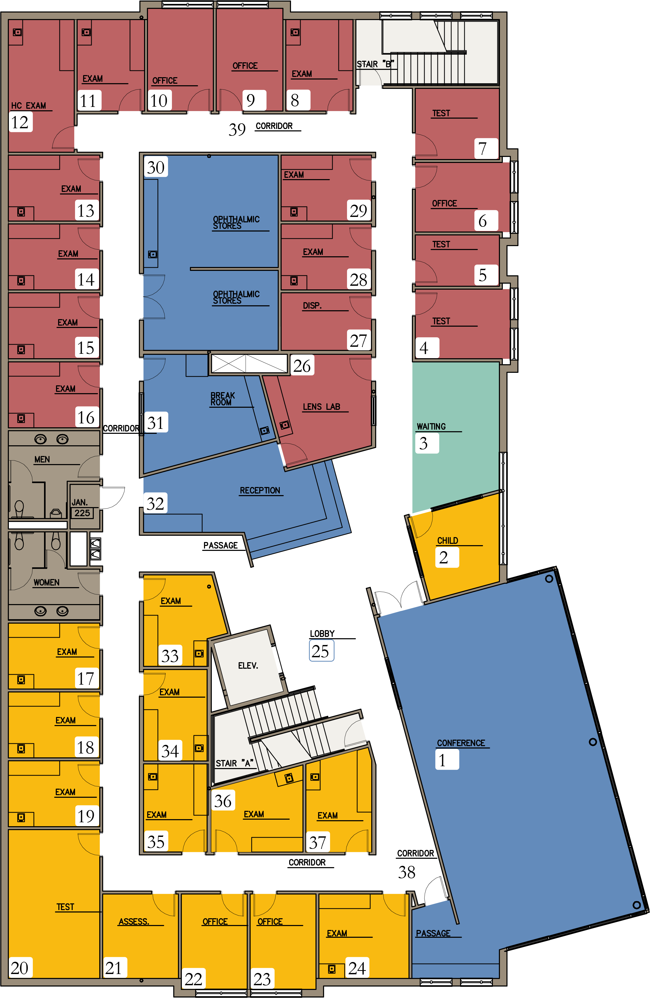

Name: ______________________________________________________________________
Device Label | Description | Unit cost | Number used | Cost

Total Cost: ______________________________
Summary of Design (including placement of devices)

